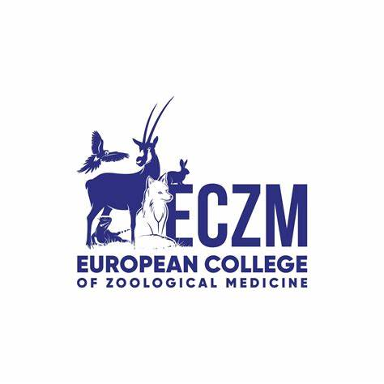**European College of Zoological Medicine**

**POLICIES & PROCEDURES, PART 2:**

**SMALL MAMMAL SPECIALTY**

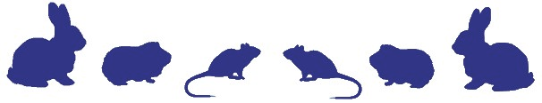

**UPDATED June 2025**

*Registered Address*:

European College of Zoological Medicine

Yalelaan 108, NL-3584 CM Utrecht, The Netherlands.

e-mail: [admin@eczm.eu](mailto:admin@eczm.eu)

website: [www.eczm.eu](http://www.eczm.eu)

The European College of Zoological Medicine (ECZM) recognises five separate specialties under the ECZM umbrella; Avian, Herpetology, Small Mammal; Wildlife Population Health and Zoo Health Management.

The Small Mammal Specialty Policies & Procedures, Part 2 document follows the structure below:

Chapter 1: Introduction

Chapter 2: Requirements for admission to the ECZM

Chapter 3: Small Mammal Residency Programmes

Chapter 4: Examination Credentialing and Application Procedure

Chapter 5: Small Mammal Approved Residency Training Sites

Chapter 6: Small Mammal Reading List

## Appendix 1: Resident Case Summary Template

Appendix 2: ECZM Small Mammal self-assessment checklist for approval of residency training sites

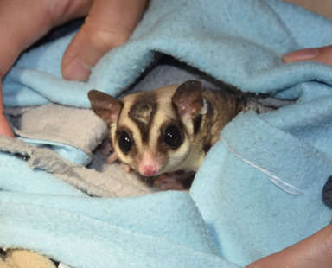

Chapter 1: Introduction

The Small Mammal specialty of the ECZM was founded in 2009. This specialty recognises a distinct branch of veterinary medicine and surgery, which has an emphasis on the veterinary care of pet rabbits, rodents and ferrets, but also includes other non-conventional small mammals kept as pets. The specialist in Small Mammals will function in academic settings or specialist practice, aiming to advance exotic mammal medicine and surgery in Europe and other parts of the world.

The Policies and Procedures, Part 2 contain information about requirements for admission to the College, a profile of the Small Mammal specialty, and application and examination procedures.

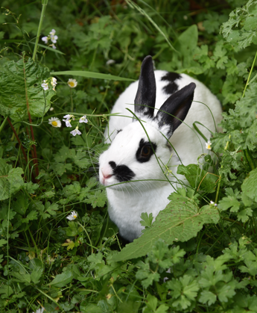Chapter 2: Requirements for admission to the ECZM

*The College admission requirements to be a Diplomate and European Specialist are specified in the Bylaws of the College, in line with the Policies and Procedures determined by the European Board of Veterinary Specialisation (EBVS). The requirements listed below are a condensed version of Chapter 4 of the Policies and Procedures, Part 1: General Information and the requirements found in Article 4 in the ECZM Constitution.*

Diplomates of the small mammal specialty appointed by the College are veterinarians who:

* Have demonstrated fitness and ability to practise small mammal medicine and surgery by meeting the established training and experience requirements as assessed by the College, including publication requirements.
* Have attained acceptable scores in the small mammal examination.
* Demonstrate moral and ethical standing in the profession and practise scientific, evidence-based veterinary medicine, which complies with animal welfare legislation.
* Practise small mammal medicine and surgery for at least 60% of their time, based on a 40-hour working week (i.e. > 24 hours/week).
* Are re-evaluated every 5 years using a standard re-certification process.

Each individual who satisfies the above requirements shall be authorised to use the designation of Diplomate of the European College of Zoological Medicine (*Small Mammal*), abbreviated to DipECZM (*Small Mammal*). The individual is also awarded, by the EBVS, the title of European Veterinary Specialist™ in Small Mammal, following successful re-evaluation every 5 years.

Each Diplomate is expected to actively participate in the scientific and business affairs of the College.

***Further information on specific requirements for prospective candidates is also found in the ECZM Policies and Procedures, Part 1: General Information.***

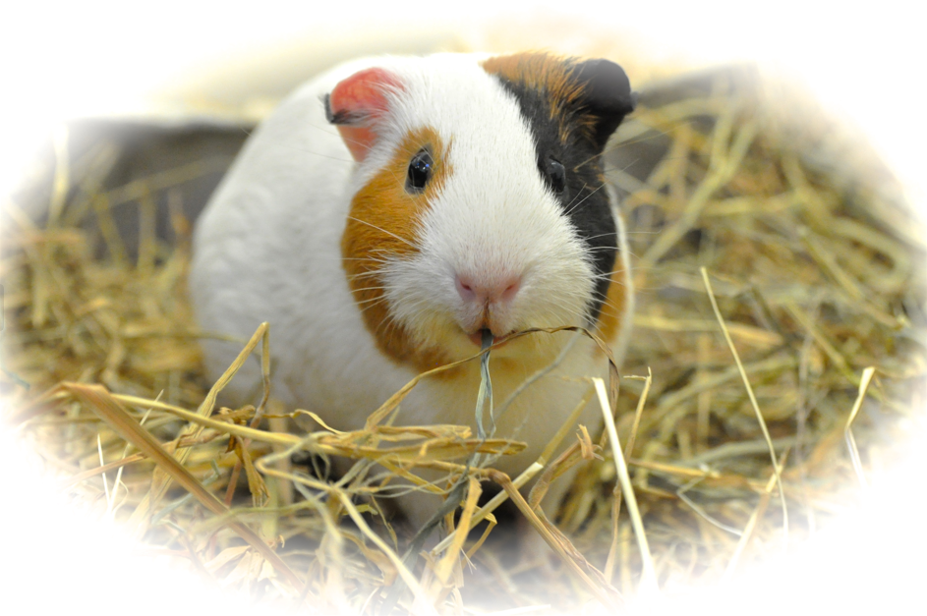

## Chapter 3: Small Mammal Residency Programmes

A Residency Programme is a training programme allowing a graduate veterinarian ("Resident") to acquire in-depth knowledge of small mammal medicine and surgery, and its supporting disciplines, under the supervision and guidance of one or more Small Mammal Diplomates (”Diplomate”).

The Residency Programme will focus on **Small Mammal Medicine** and aims to:

* Instil theoretical knowledge, applied practical skills and an ethical attitude in the practice of small mammal medicine.
* Provide the Resident with the opportunity to pursue career goals in teaching, research, service, and/or specialty practice.
* Prepare the Resident for the Small Mammal examination.

**A. Detailed Objectives of the Small Mammal Residency Training Programme**

* The small mammal specialist is expected to know the taxonomy and the geographical distribution of the different groups of small mammals as commonly kept, including those groups of animals, which are common wild animal casualties (i.e. rabbits, squirrels and hedgehogs).
* The small mammal specialist should understand the natural history of all the above groups, particularly their feeding habits and nutritional requirements. Also which animals are territorial (always or only during breeding) and which are potentially aggressive and predatory.
* Basic knowledge of general anatomy, physiology and immunology, relating to the small mammal specialty is expected. The specialist should know important variations between the different orders and families of animals as relevant to the specialty.
* The small mammal specialist must be able to assess diets, understand the formulation of diets for animals and know the current trends in animal nutrition. The specialist should know of the interaction of nutrition and health.
* A small mammal specialist should be familiar with the various aspects of captive care, husbandry, and management, including propagation, neonate and developmental care. The candidate must understand genetic principles and their application in the small mammal specialty.
* A detailed knowledge of the small mammal diseases (aetiology, epidemiology, pathology, diagnosis, treatment and control) is required. It is not sufficient to know only the pathogens responsible for a disease, but it is also important to know of which types of disease occur more commonly in various groups of animals. Small Mammal specialists need to know the gross pathology of each disease but will realise that a specific diagnosis can only be confirmed by using appropriate laboratory techniques.
* Small Mammal specialists must be familiar with common toxins, which are most likely to affect various groups of their patients. They must know the clinical signs these toxins produce and be familiar with the differential diagnosis. Small Mammal specialists will need to know which body tissues and specimens are required by a laboratory for the identification of the toxin.
* A detailed knowledge of the advanced diagnostic possibilities in their small mammal patients, in relation to medicine (e.g. haematology, blood chemistry, endocrine tests, immunological tests, diagnostic imaging, including gastrointestinal contrast studies, diagnostic endoscopy, electrocardiography, fine-needle aspiration, microbiology, cytology) and the ability to interpret results of these techniques is expected.
* Small Mammal specialists must know of the principles of individual and group medication in their patients. This includes knowledge of the pharmacokinetics and the bioavailability of drugs suitable for treatment and the various methods of administration.
* The small mammal specialist must be acquainted with the social role and the responsibilities of the specialist regarding their patients, clients, colleagues, public health and environmental issues. The specialist must also be able to express and support views on current issues relevant to this field of knowledge.
* It is necessary to know of the legislation affecting the small mammal field and to know of the legislation relating to the role of the veterinary practitioner in the field (e.g. Convention on International Trade in Endangered Species of Wild Fauna and Flora [CITES], legislation concerning the import and export of animals, animal welfare, legislation on hunting and capture from the wild, the use of drugs and immune-biologicals).
* Theoretical knowledge should be to the level of current textbooks. It is essential to know the relevant scientific literature published over the previous five years in representative journals as detailed in the small mammal reading list.
* The small mammal specialist should have had extensive practical experience with a wide variety of species relevant to the specialty.
* The small mammal specialist must be competent in the various skills associated with the field including history taking, catching and handling his patients, and clinical examination of animals for assessment of health, clinical pathology sample collection, vaccination and medication methods and in addition anaesthetic and surgical procedures.
* The small mammal specialist should be familiar with the techniques of radiosurgery, endoscopy and know about such routine techniques as dental treatment, the principles of orthopaedic surgery, surgery of the gastrointestinal tract, the respiratory tract and reproductive tracts, etc.
* A specialist in small mammal medicine shall be able to handle emergencies in small mammal patients.

**B. Small Mammal Training programme description**

The residency programme will focus on all aspects of small mammal medicine and be supervised by a Small Mammal Diplomate.

Prerequisites for Specialty Training

Details of the training required before undertaking a residency programme can be found in section 5.2 of the Policies and Procedures, Part 1, General Information.

This first period must be a one-year rotating multi-disciplinary internship (in any species) or 2 years in general practice. This period of training must be approved by the Education and Residency Committee before starting a residency training programme, but *pre-approval* of this training period is not required.

### Residency Programme Description

A second period shall comprise a three-year (minimum) postgraduate training programme (standard residency) or an alternate programme under the supervision of a Small Mammal Diplomate of ECZM.

The period is designed to educate the Resident primarily in the art and science of small mammal medicine. There shall be additional instruction in the related disciplines of anatomy, physiology, diagnostic imaging, anaesthesiology, ophthalmology, clinical pathology, surgery, clinical nutrition, epidemiology, preventive medicine, and gross pathology.

The specific requirements for a standard residency programme or an alternate route can be found in chapter 5 of the Policies and Procedures, Part 1: General Information and, in particular, sections 5.3 – 5.6.

Other Duties

At least 20% of the residents programme must be off clinical duties. During this time residents must fulfil their requirements for research, publications and speaking engagements. In addition, any or all of the following activities can also be undertaken in this time:

1. Research or clinical investigation.

2. Preparation of scientific manuscripts.

3. External small mammal rotations with the approval of the supervisor.

4. Anaesthesiology, diagnostic imaging, and pathology requirements as described below.

5. External rotation at alternative specialist sites in animals or disciplines to which they would otherwise be minimally exposed, or to gain additional experience with novel techniques or equipment.

**C. Specific Small Mammal Residency Programme Content**

Small mammal medical service rotations facilitate the development of the knowledge, skill, and proficiency in the respective specialty via exposure to a wide variety of respective diseases with the guidance and collaboration of experienced specialists in the specialty.

At least 60% of the 3-year programme must be spent on a small mammal medical and surgical service under the supervision of an ECZM Small Mammal Diplomate. The degree of responsibility assumed by the Resident shall be appropriate to the nature of the procedure and training experience. The Resident on a small mammal medical and surgical service shall be responsible for:

a) Receiving clinic appointments.

b) Supervising daily management of hospitalised animals.

c) Participation in clinical teaching.

d) Providing optimal clinical service and prompt, professional communications.

e) Participation in a small mammal medical and surgical emergency service.

If the required additional training has not been performed before the residency, the following rotations are to be done during this period:

A. Anaesthesiology

The Resident must obtain a total of 10 days of training under the supervision of a Diplomate of the European or American College of Veterinary Anaesthesiologists or their equivalent.

B. Diagnostic Imaging

The Resident must obtain a total of 10 days of training under the supervision of a Diplomate of the European or American College of Veterinary Diagnostic Imaging or their equivalent. Alternatively, radiological and ultrasonic interpretation of the clinical cases of the Resident should be performed under the supervision of a Diplomate in diagnostic imaging.

C. Surgery

The Resident must obtain a total of twenty days instruction and training on basic surgical principles and radiosurgery under the supervision of a Diplomate of the European or American College of Veterinary Surgery, or their equivalent.

D. Small Mammal Pathology

The Resident must obtain at least 65 days of training under the supervision of a Diplomate of the European or American College of Veterinary Pathology or their equivalent. Alternatively, the resident may carry out 20 days of training under the supervision of a Diplomate in Pathology in addition to evaluating 30 post-mortem examinations of small mammal patients. Those 30 post-mortem case reports need to be verified by a Diplomate of the European or American College of Veterinary Pathology, or their equivalent or a pathologist approved by the Education and Residency Committee. The Resident should be encouraged to present or attend patient rounds and clinical case presentations. ‘Pathology’ can be defined as 20 days of ‘Anatomical Pathology’ or divided as 10 days of ‘Anatomical Pathology’ and 10 days of ‘Clinical Pathology’.

*Residents may spend time at multiple centres to achieve the required standard during the programme.*

**D. Facilities, Services, and Equipment Required in a Small Mammal Residency Programme.**

The approved programme must be based at a centre with the following facilities:

A. Medical library: a library containing recent textbooks and current journals relating to small mammal medicine and surgery and its supporting disciplines must be immediately accessible to the programme participants (working collection).

B. Medical records: a complete medical record must be maintained for each case and rapid retrieval of information about any patient or group should be possible.

C. Radiographic services: separate rooms and appropriate equipment for comprehensive diagnostic imaging must be available.

D. Pathology services:

1. Clinical pathology: a clinical pathology laboratory for haematology, clinical chemistry, microbiology, and cytological diagnosis must be available. Clinical pathology reports must be retained and retrievable.

2. Morphologic pathology: a separate room for gross pathologic examination must be available. Facilities for histopathologic examination of necropsy tissues must be available. Anatomic pathology reports must be retained and retrievable.

E. Medical and surgical facilities:

1. Clinical examination rooms: the examination rooms must be designed, constructed, used, and maintained consistent with the current concepts of practice. They must be sufficient in number and size to accommodate the case load.

2. Treatment areas: Areas for intensive care, special procedures, isolation, and good nursing must be available. Intensive care units in the form of an incubator with heat control and oxygen delivery system are mandatory. Consideration of biosecurity and control of pathogen spread between patients is advisory.

3. Operating room: the operating rooms must be designed, constructed, used and maintained consistent with current concepts of veterinary surgery. The surgery room(s) must be sized adequately for the patient, staff, and associated equipment. The sterile surgery room(s) must be ventilated according to the current concepts of aseptic surgery. Emergency lighting must be available. In accordance with modern standards, the sterile theatre should not be used for any other purposes.

4. Anaesthetic and critical care equipment: appropriate anaesthetic and critical care equipment must be available. An isoflurane vaporiser with an adequate scavenging system is mandatory. Routine monitoring of surgical patients with respiratory or cardiac monitors is required.

5. Surgical instrumentation: a full complement of general and special instrumentation for diagnostic and surgical procedures must be available. Ophthalmologic equipment and orthopaedic instrumentation sufficient for current standards of practice must be present.

6. Photography: photographic equipment for the documentation of disease must be available.

7. Sterilisation: steam and heat sterilisation of surgical instrumentation and supplies must be available, and the sterilisation capacity must be commensurate with the caseload.

**E. Case Numbers and Case Logs.**

The caseload of the institution must be large enough to afford the candidate adequate exposure to all required phases of practice of small mammal medicine. The minimum acceptable number of accessions will depend upon the difficulty of the problem and the extent of treatment provided, but should be divided over a range of different procedures and species. The Resident should be involved in a minimum of 10 small mammal cases per week, and at least 450 patients during the entire residency period.

While a minimum case load is necessary to develop clinical experience, the candidate must also be provided with sufficient time to evaluate patients properly, to study, and to participate in rounds, workshops, work with other Board-Certified Specialists and to lecture.

**F. Documentation**

The Resident maintains and submits the reporting package to the Education and Residency Committee as described in Policies and Procedures; Part 1, sections 5.6.

The Small Mammal specialty is a clinical residency programme and therefore follows the report submission frequency of 3-3-6-6-6-6 months, each period termed a “residency phase” (See Policies and Procedures: Part 1, section 5.6.1). The reports must be maintained and submitted in the Education and Residency Committee approved specialty report templates, as described below. A set of small mammal case log documents is available on the website.

Two reports are completed by the resident (the Case Log and the Resident Progress Report) and one report (Supervisor Progress Report) by the supervisor for evaluation by the Education and Residency Committee.

**1. The Case Log is submitted by the Resident. It contains:**

***1. Medical and Surgical Case Log***

A Medical and Surgical Case (MSC) Log listing the date of procedure, case number (running total), species, diagnosis, medical or surgical procedure, designation as elective or emergency, and responsibility as assistant or primary clinician must be maintained by the Resident. The Resident may be considered the primary clinician when that individual can document a significant role in the following aspects of management: determination or confirmation of the diagnosis, provision of preoperative care, selection and performance of appropriate surgical procedures, direction of the postoperative care, and accomplishments of sufficient follow-up to be acquainted with the course of the disease and the outcome of its treatment. Where a case is seen several times, all follow-up visits should appear with the initial examination, but dated with the date of each follow-up examination.

Besides the MSC log, which is submitted every 3 to 6 months, the Resident shall retain (or be able to retrospectively create from clinical records) a single page record of each case examined. The Resident will be requested to submit random examples of these sheets, after submission of the case log. The template for this is presented in Appendix 1.

***2. Resident Procedures Log***

A Resident procedures log must be maintained within the Small Mammal Case Log. It must list a running total of diagnostic and therapeutic procedures performed, case number, signalment, procedure performed, and results.

***3. Resident Post-Mortem Log***

A Resident Post-Mortem log, which contains the case number, signalment, date, diagnosis, complications/reason for mortality, post-mortem diagnosis if applicable, shall be maintained. This log contains cases from the case logs in which unexpected complications (morbidity/mortality) have occurred. It may also contain the 30 supervised cases if that option is chosen above.

***A Resident Activity Log is submitted by the Resident. It is part of the Case Log and consists of:***

***4. Continuing Education Log***

The Resident must maintain a Resident Continuing Education Log listing internal (in-house) Continuing Professional Development (CPD) such as journal clubs, seminars and lectures, conferences (national and international) and meetings attended, and

***5. Resident Presentation Log***

The Resident must maintain a Resident Presentation Log listing the presentations given at national and international zoological medicine conferences and other professional meetings.

**6. Resident Peer-Reviewed Publications Log**

The Resident must maintain a Resident Peer-Reviewed Publications Log, listing peer-reviewed publications authored by the Resident.

***B Resident Progress Report. It is separate from the Case Log.***

The Progress Report contains a summary of the Resident's activity during each residency phase. It includes an overview of the residency, consisting of the number of cases seen in the residency phase and 3-year residency, days of specialist training that have been completed in the various disciplines, number of international conferences attended, progress with the 5 required case reports, progress with the research project(s), number of publications in peer-reviewed journals authored by the resident, and presentations/lectures either in-house or at conferences/meetings.

**2. Supervisor Progress Report**

Similar to the Resident, the Resident Supervisor will also submit a Supervisor Progress Report to the Education and Residency Committee, in which the supervisor states that he/she has seen and verified the Case Log submitted by the Resident, as well as his/her expectations with regard to completion of the residency and additional concerns and/or actions to be taken.

The Resident Progress Report and Supervisor Progress Report are combined on one Education and Residency Committee form entitled ‘ECZM -Small Mammal Residency Progress Report.’

In addition, the Resident must complete an annual **Residency Evaluation Form**. This is submitted to the Chair of the Education and Residency Committee and allows the Resident to evaluate the residency programme they are participating in. The information is strictly confidential and if problems are raised, the Chair will contact the Resident privately to discuss things further.

Residents must meet with the Programme Supervisor at least twice yearly for evaluation of performance and progress. When the Resident has multiple supervisors, this meeting should be preceded by a meeting among the supervisors.

***Late submission of reports at the end of a residency phase may be subject to sanctions as detailed in section 5.6.3 of the Policies and Procedures; Part 1; General Information***

**G. Research, Publications and Speaking Requirements**

The research, publication and speaking requirements should be performed in the allocated time for other duties (See B. Small Mammal Training programme description. Other Duties)

Publications:

The Resident must complete peer-reviewed papers in small mammal medicine, published in a well-established internationally refereed scientific journal (i.e., mentioned in the Science Citation Index or on the small mammals’ specialty reading list).   
  
EITHER

1. Three (3) publications:  
   One (1) of these papers must be the result of an original research project, which was carried out within the residency period, and the applicant must be the first author. The other two can be original scientific research, a case series or a single case report, and the applicant should be a contributing, but not necessarily, the principal author.   
     
   OR
2. Two (2) publications:

Both publications as the primary author, one (1) of these papers must be the result of an original research project, which was carried out within the residency period. The other one (1) can be original scientific research, a case series or a single case report.

* First author co-authorships between different residents will only be accepted under the condition that all first authors can demonstrate an equal contribution to the article, and that they worked individually in different parts of the article, but that they present it in a single paper in order to make the article stronger.
* All publications meeting the requirements mentioned above will be acknowledged if they were published or accepted for publication within the 5 years leading up to credentialing for the examination. This should be evidenced by a letter from the editor.
* Either all publications should be accepted and published at time of credentialing or all, bar one, must be accepted or published. Of the one yet to be published, it should be evidenced, at the time of credentialing, with a letter from the editor, that it has been submitted for publication. In this case, the successfully examined candidate will not gain diplomate status until the publication has been published.

Other Requirements:

**Continuing Professional Development**: A minimum of fifty hours of formal continuing education is required per year. External continuing education may be within the local, regional, national or international meetings in the specialty. It should include participation in wet labs. All activities in this area must be recorded in the ***Resident Continuing Education Log***. Internal continuing education at the institution consists of participation in journal clubs, case presentation seminars and wet labs, which are organised as part of the residency.

The time allocated to small mammal journal clubs should be equivalent to 1 hour per week during the supervised clinical period of the Resident (60 hours in total for a regular residency). The journal club should be under the direct supervision of the supervisor. However, it is advised that journal clubs are set amongst small mammal residents and supervisors on a rotation basis. The journal club is defined as a presentation and a discussion on articles or book chapters included in the reading list. Alternatively, the Resident can prepare a presentation with a literature review on a topic favouring the use of literature material from the reading list. The small mammal journal clubs should be written in the Resident Continuing Education Log in the dedicated table with the date, the duration and the topic. Residents are encouraged to assist other specialties journal clubs, which will be written in another table and will also count as continuing education.

**Clinical Rounds**: The Resident should be encouraged to present or attend patient rounds and clinical case presentations where possible. In addition, the Resident should participate in the clinical education of graduate veterinarians and/or veterinary medical students within the field of small mammal medicine.

**Conferences**: Attendance of at least **two (2)** international conferences, relevant to small mammal medicine, with active participation in wet labs is required during the residency period.

**Seminars**: Present a minimum of **two (2)** one-hour seminars per year in a formal setting with attendance of other veterinarians. A seminar is defined as a scientific presentation followed by a discussion period.

**Presentations**: The Resident should aim to present cases regularly at scientific conferences. At least **once** during the residency, the Resident must speak at an international conference on material relevant to the small mammal discipline.

Chapter 4: Examination Credentialing and Application Procedure

**Examination Credentialing**

The process, documentation, and deadlines required to credential to sit an ECZM examination is detailed in chapter 6 of the Policies and Procedures, Part 1: General Information.

Listed below is a **summarised** version of the section concerning the Small Mammal specialty requirements. Applicants are advised to refer to **BOTH** this list and section 6.4. of the Policies and Procedures, Part 1: General Information, to submit a complete application for examination credentialing.

* **Covering Letter.**
* **Curriculum Vitae.**
* **Reference letter(s)** from the Programme Supervisor(s) of each institution involved in the training programme.
* **Documentation logs**. For Small Mammal these include the *Medical and Surgical Case Log*, *Resident Procedures* *Log, Resident Post-Mortem Log, Resident Continuing Education Log, Resident Presentation Log* and *Resident Log and Programme Summary.* If the training programme is not yet finished, then the logs must be complete up to the time of application.
* **Publications**. The resident must complete either 2 first author publications or 1 first author and 2 co-authored publications. Further requirements are explained in section G.
* Any relevant previous correspondence relating to the training programme and application.
* Evidence of payment of ***Credentialing for Examination* fee**.

The application materials must be arranged as detailed above and sent electronically to the ECZM Secretary before the deadline. Any subsequent correspondence should be through the Secretary unless advised otherwise. All submitted application materials become the sole property of the ECZM and will not be returned to the applicant.

## Applying for and sitting the examination

The Small Mammal specialty examination and application process follows the general format of all College examinations as detailed in **Chapter 7** of the Policies and Procedures, Part 1: General Information. Candidates are advised to read that chapter alongside this section, so they are informed about all aspects of the application and examination.

The Small Mammal specialty examination will aim to test all aspects of small mammal medicine and surgery. It has two sections:

1. Written section containing multiple-choice questions

This section consists of 100 multiple-choice questions each worth one point. The pass mark is 65%. There will be an incremental increase over three years in the number of multiple-choice questions starting from 2021. The incremental increase will be as follows:

- 2021: 125 questions, 3 hours duration (with no additional perusal time)

- 2022: 150 questions, 3.5 hours duration (with no additional perusal time)

- 2023: 175 questions, 4 hours duration (with no additional perusal time)

Each multiple-choice question consists of two parts: the stem and the responses. The stem is the introductory statement or question. The responses are suggested answers that complete the statement or answer the question asked in the stem. For each question, there is one correct response, and four distractors.

2. Practical/written section designed to test interpretive skills

The second part is the practical/written part of the exam and contains 27 questions that relate to appropriate small mammal clinical or management situations. Each question is worth 10 points (total available this section; 270 points). The pass mark is 65%. The total duration of the exam is 4 hours. To help the candidates ensure a good perusal of their time, the 27 questions are divided into 9 sets of three questions. Invigilators will call out every 20 minutes for the candidate to move on to the next set of questions, so that the candidate has gone through the entire exam after 180 minutes. The last hour can subsequently be used by the candidates to go back and review any question they would like, before the exam papers are handed in to the examiner.

The integrity of the Diplomate status examination will be maintained by the ECZM to ensure the validity of scores awarded to candidates.

Obligations for the successful examination candidate and requirements for re-application for an examination, along with all other policies and deadlines regarding the exam are found in **Chapter 7** of the Policies and Procedures, Part 1: General Information.

Chapter 5: Small Mammal Approved Residency Training Sites

Hospital Clinic Veterinari, Facultat de Veterinària, Universitat Autònoma de Barcelona, **Spain**

Supervisor: Jaume Martorell

[Jaumemiquel.martorell@uab.es](mailto:Jaumemiquel.martorell@uab.es)

Ecole Nationale Vétérinaire d'Alfort, Centre Hospitalier Universitaire Vétérinaire d'Alfort, Avenue du Général de Gaulle, Maisons-Alfort, Paris, **France**

Supervisors: Charly Pignon

[charly.pignon@vet-alfort.fr](mailto:charly.pignon@vet-alfort.fr)

Advetia Centre Hospitalier Vétérinaire, 9 Avenue Louis Breguet, 78140 Vélizy-Villacoublay, **France**

Supervisor: Jean-Francois Quinton

jeanfrancoisquinton@yahoo.fr

Clinique Vétérinaire l’Arche des NAC, 20 rue Lavoisier, 95300, Pontoise, **France**

Supervisor: Véronique Mentre

[drmentre@archedesnac.com](mailto:drmentre@archedesnac.com)

Clinique vétérinaire, Exotic Clinic, 38 rue d'Arcueil, 77176 Nandy, **France**

Supervisor: Lucas Flenghi

[lucas.flenghi@orange.fr](mailto:lucas.flenghi@orange.fr)

### Ghent University, Department Pathobiology, Pharmacology and Zoological Medicine, Division of Poultry, Exotic Companion, Wildlife and Laboratory Animals, Belgium.

### Supervisor: Katleen Hermans

[Katleen.Hermans@ugent.be](mailto:Katleen.Hermans@ugent.be)

Centro Veterinario Specialistico per animali esotici, Rome, **Italy**.

Supervisor: Paolo Selleri

[paolsell@gmail.com](mailto:paolsell@gmail.com)

Rabbit, Exotic Animal and Wildlife Practice, The Royal (Dick) School of Veterinary Studies, University of Edinburgh, **Scotland**, United Kingdom.

Supervisor: Jenna Richardson

[Jenna.Richardson@ed.ac.uk](mailto:Jenna.Richardson@ed.ac.uk)

Utrecht University, Division of Zoological Medicine, Yalelaan 108, 3584 CM Utrecht, The **Netherlands**.

Supervisor: Nico Schoemaker

[n.j.schoemaker@uu.nl](mailto:n.j.schoemaker@uu.nl)

University of Saskatchewan, Western College of Veterinary Medicine, 52 Campus Dr, Saskatoon, **Canada**

Supervisor: Isabelle Desprez

[isabelle.desprez@gmail.com](mailto:isabelle.desprez@gmail.com)

Chapter 6: Small Mammal Reading List (valid for the 2025 examination and onwards)

This document should assist residents in compiling a list of textbooks and journals that should be read before sitting the ECZM Small Mammal examination. The Resident and program supervisor should ensure these are available at the main institution where the Resident works, either as part of the university or practice library, or owned personally by the Resident or supervisor. The Resident must have access to the entire reading list as this forms the basis of the examination. The Resident should ensure they have the latest edition for examination preparation as the examination team may have added additional texts and journals.

Such a list cannot be comprehensive and cover all current information on the discipline. It is the Resident’s responsibility (assisted by their supervisor) to ensure they are current on all information in the field.

The reading list will be circulated by the chairperson at least 3 months before the Annual General Meeting (AGM) for the members of the Small Mammal specialty to put forward any up-to-date alterations. Those will then be integrated into the reading list, aiming to keep to a page limit of 10,000 pages.

All Diplomates are required to refer to Nomina Anatomica Veterinaria (NAV) for anatomical nomenclature.

**List of journals** (last 5 years), only articles clinically relevant to the specialty:

American Journal of Veterinary Research

Journal of the American Animal Hospital Association

Journal of the American Veterinary Medical Association

Journal of Small Animal Practice

Journal of Exotic Pet Medicine

Veterinary Clinics of North America, Exotic Animal Practice

The Veterinary Record

The Veterinary Journal

Veterinary Dermatology

Veterinary Ophthalmology

Veterinary Clinical Pathology

Veterinary Radiology & Ultrasound

Journal of Veterinary Diagnostic Investigation

**Non-listed paper:**

Fritz, J., H. Gaillot, and Y. Ruel. "Helical computed tomographic-dacryocystography in adult pet dwarf rabbits: procedure and normal appearance." *Vlaams Diergeneeskundig Tijdschrift* 89.6 (2020).

**Monographs**

|  |  |  |
| --- | --- | --- |
| **Number** | **Books and Ebooks** | **Pages** |
| 1 | Barthold SW, Griffey SM, Percy DH (eds): Pathology of Laboratory Rodents and Rabbits, 4th edition, Wiley Blackwell, 2016. | 384 |
| 2 | Böhmer, E. Dentistry in Rabbits and Rodents, Wiley-Blackwell, 2015 | 296 |
| 3 | Capello V, Gracis M, Lennox AM (eds): Rabbit and Rodent Dentistry Handbook. Zoological Education Network, 2005 (**electronic Version**) | 270 |
| 4 | Capello V, Lennox AM, Widmer WR (ed). Clinical radiology of exotic companion mammals. Ames: Wiley-Blackwell 2008 (**electronic Version**) | 490 |
| 5 | Capello V, Mancinelli E, Lennox A, Kling M (ed). Ear surgery of pet rabbits. Milano, Italy: ebooksdynamic.vet; 2015. (**electronic Version**) | 80 |
| 6 | Fox JG, Marini RP, Biology and Diseases of the Ferret, 3rd edition, Wiley, 2014. Namely Chapter 2 (45 p), 4 (42 p), 8 (13 p), section II, Chapters 11-21 and 24 | 362 |
| 7 | Harcourt-Brown F, Chitty J (eds). BSAVA Manual of Rabbit Surgery, Dentistry and Imaging. British Small Animal Veterinary Association, Gloucester, 2016 | 434 |
| 8 | Johnson Delaney, C. Ferret Medicine and Surgery. CRC Press, Baton Rougue, 2016. ** EXCLUDING surgery chapters | 544 |
| 9 | Krautwald-Junghanns M., Pees M.; Reese S., Tully T. Diagnostic Imaging of exotic pets. Schlutersche, 2010. (ONLY SMALL MAMMAL PARTS | 165 |
| 10 | Mayer J, Donnelly TM. Clinical veterinary advisor. Birds and exotic pets. St. Louis, MO: Elsevier/Saunders, 2013. (SMALL MAMMAL RELATED CHAPTERS ONLY) | 297 |
| 11 | Meredith A, Lord, B. (eds): BSAVA Manual of Rabbit Medicine. BSAVA - British Small Animal Veterinary Association, Gloucester, 2016 | 321 |
| 12 | O’Malley B. Clinical anatomy and physiology of exotic species: structure and function of mammals, birds, reptiles, and amphibians. Edinburgh/New York: Elsevier Saunders, 2005. (SMALL MAMMAL RELATED CHAPTERS ONLY) | 98 |
| 13 | Quesenberry KE, Orcutt CJ, Mans C, Carpenter JW (eds): Ferrets, rabbits and rodents: clinical medicine and surgery. 4th ed. St. Louis, Missouri, Elsevier, 2021. | 630 |
| 14 | Thrall, MA. Veterinary Hematology and Clinical Chemistry Wilkins Blackwell ONLY SMALL MAMMAL CHAPTERS, i.e. chapter 16 and 31 | 30 |
| 15 | Tynes V (ed): Behavior of Exotic Pets, Wiley-Blackwell, 2010. Small mammal related chapters ( ferrets [10 p], rabbits [9 p], guinea pigs [13 p], mice [13 p], rats [13 p], gerbils [10 p], hamsters [11 p], chinchillas [10 p], prairie dogs [9 p], hedgehogs [13 p], sugar gliders [9 p]) as well as three general chapters on universal principles of learning [16 p], behavioral pharmacology [9 p] and welfare of exotic animals in captivity [10 p]. | 155 |
| 16 | Varga Smith M. Textbook of Rabbit Medicine. 3rd edn. Elsevier, St. Louis, Missouri, 2022 | 592 |
| 17 | Williams DL. Ophthalmology of Exotic Pets. 1st edn. Wiley-Blackwell, Oxford, 2012 (SMALL MAMMAL RELATED CHAPTERS ONLY) | 104 |
| Total | | **5200** |

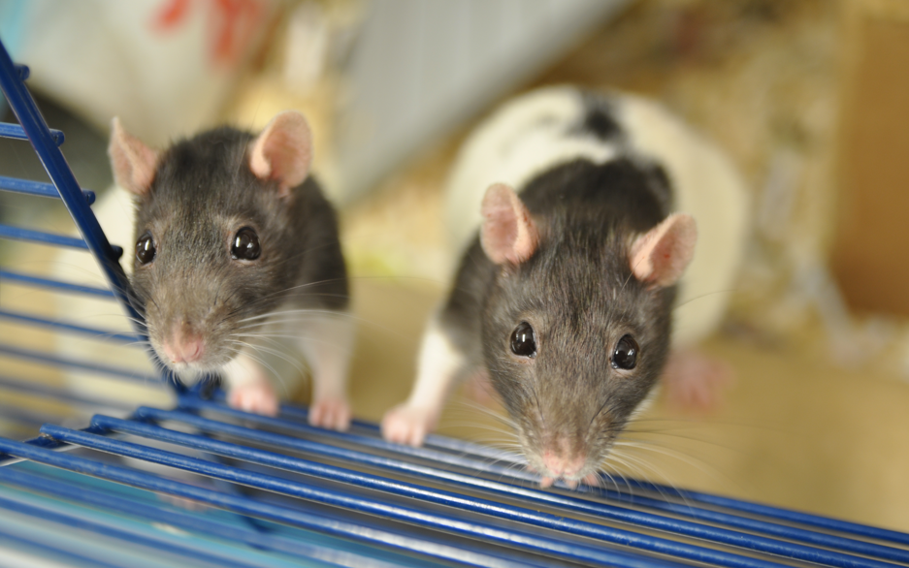**LAST UPDATED May 2024**

## Appendix 1: Resident Case Summary Template

Reference No

Date

Common Name

Latin Name

History

Reason for presentation

Presenting Signs and Symptoms

Diagnostic Procedures

Physical

CBC

Biochemistry

Cytology

Radiology

Ultrasonography

Other

Treatment (to include drugs, dose rate, frequency and route of administration)

Response to therapy

Case Outcome

Appendix 2: ECZM Small Mammal self-assessment checklist for approval of residency training sites

Small Mammal Facility Name:

Purpose of inspection:

√ Approval as a residency training centre for ECZM

√ Re-inspection after 5 years

√ Re-inspection due to meaningful changes within the residency site (indicate which changes)

Date inspection conducted:

Inspector names:

Facility Representative names:

|  |  |
| --- | --- |
| Case load of the institution must be large enough to afford the candidate adequate exposure to all required phases of practice.  The case load should consist of at least 10 (ten) relevant cases per week.  Total number of cases over past 5 years  Year 1  Year 2  Year 3  Year 4  Year 5  Describe percentage of animal species seen   * Ferret * Rabbit * Guinea pig * Small rodents (rat, mouse, hamster) * Other small mammals (list species)   Describe percentage of procedures performed   * Emergency and after-hours * Diagnostic procedures other than blood collection (specify) * Diagnostic Imaging:   + Radiography   + Ultrasound   + Other (specify) * Surgery   + Neutering   + Soft tissue other than neutering   + Orthopaedic   + Dental * Necropsy   + With histopathology   + Without histopathology |  |
| Medical records: a complete medical record must be maintained for each individual case and rapid retrieval of information for a patient or group of patients should be possible.  √ Can diagnostic imaging and clinical pathology reports and other relevant case information be stored and retrieved for each case?  √ How is information on hospitalised patients recorded? |  |
| Clinical examination rooms: the examination rooms must be designed, constructed, used, and maintained consistent with best current practices  √ Sufficient in number and size to accommodate the case load?  √ Appropriate in design? |  |
| Hospitalisation areas that ensure good nursing must be available with consideration given to biosecurity and control of pathogen spread between patients.  √ Separate cages with heat / humidity control and oxygen delivery available?  √ Recording of treatments and progress of the patient?  Isolation facilities/Quarantine areas that include appropriate consideration given to biosecurity and control of pathogen spread between units must be present.  √ Appropriate isolation facilities available?  √ Individual equipment available? |  |
| Diagnostic imaging equipment must be used and interpretation conducted by the residents. Radiation monitoring is mandatory.  √ Labelling, recording and filing of all images and reports  √ Safety monitoring is put into place?  √ Radiography equipment available?  √ Ultrasound equipment available?  √ Endoscopy equipment available, including for biopsy collection?  √ ECG available?  √ MRI, fluoroscopy, CT available or available by an external centre? |  |
| Clinical pathology: a clinical pathology laboratory for haematological, clinical chemistry, microbiological, and cytological diagnosis must be available. Clinical pathology reports must be retained and retrievable.  √ Microscope and equipment for staining slides is available?  √ Blood chemistry bench top analyser/ blood gas analyser available or available by an external laboratory?  √ Microbiology available on site or by an external laboratory? |  |
| Operating rooms must be designed, constructed, used and maintained consistent with best current practices  √ must be used only for surgery  √ must be sized adequately for the patient, staff and associated equipment.  √ must be ventilated appropriately  √ Emergency power available? |  |
| Anaesthetic and critical care equipment: must be available.  √ A range of induction masks and endotracheal tubes are available  √ Anaesthetic gas vaporiser available  √ Adequate scavenging system?  √ Anaesthetic monitoring equipment?  √ Suitable volatile and parenteral agents available?  √ Emergency resuscitation equipment is readily available?  √ Anaesthetic records are maintained? |  |
| Surgical equipment: a full complement of general and special surgical instruments for diagnostic and surgical procedures must be available.  √ Appropriate surgical equipment  √ Dental surgical equipment  √ Micro-surgery equipment?  √ Magnification and good illumination equipment?  √ Suitable suture material available?  √ Electrosurgery equipment is available? |  |
| Sterilisation: Steam, heat, radiation and/or chemical sterilisation of surgical instruments and supplies must be available.  √ Sterilisation equipment?  √ Verification of sterilisation?  √ Labelling and dating of all sterilised instruments? |  |
| Photography: photographic equipment for documentation of disease must be available.  √ Digital camera and software for image storage |  |
| Medical library: a library containing textbooks and journals (or access to e-textbooks and e-journals) relating to small mammal medicine and its supporting disciplines must be immediately accessible to the resident. Medical library needs to be current with the ECZM reading list.  √ Does the resident have access to all titles on the current reading list? |  |
| Staff: Resident should work with multiple veterinarians, veterinary technicians and animal keepers.  √ How many veterinarians are on staff?  √ How many veterinary technician / specialised keepers? |  |

For self-assessment:

Provide a series of photographs documenting the facilities and equipment.

I, the Programme Supervisor, attest that this self-inspection report is an accurate indication of available facilities and equipment, and will provide additional information or documentation as requested by the Education Committee.

Signed Date

For Inspection Visit:

Inspectors recommendations

The following mandatory conditions are made:

The following non-mandatory recommendations are made:

Signed Date